|  |  |  |  |
| --- | --- | --- | --- |
| **Campus** | **NPI** |  | Please Tick (✓) for  **Re-do Assignment** |
| **APU Foundation & Degree**  **Programmes** | |  |

**Coursework Submission and Feedback Form**

|  |  |  |  |  |  |
| --- | --- | --- | --- | --- | --- |
| **Name** | **Sajag Shrestha** | | | | **Name of Group Members (If Applicable)** |
| **Student No.** | **NPI000172** | | **Intake:** | **NPI1F2202IT** | **Aashish Khadka(NPI000138)** |
| **Module Code & Title** | **System Analysis & Design (CT026-3-1-SAAD)** | | | | **Adarsha Timsina(NPI000139)** |
| **Assignment Title** | **Design a management system for One Pacific Health Club** | | | | **Nabin Adhikari( NPI000158)** |
| **Name of Lecturer** | **Mr. Jupitar Tamrakar** | | | | **Saiyam Rana(NPI000171)** |
| **Date Due** | **03 July 2022** | **E-Mail: sajagcrestha@gmail.com** | | | **Sajag Shrestha(NPI000172)** |
| **Tej Bahadur Gharti Kshetri (NPI000183)** |

*I have read and understood the regulations on Plagiarism and Academic Dishonesty and declare that the work submitted does not breach those regulations.* **Signed: ________________________________**

**You must hand in to the designated APU Administrator – ensure that you receive your receipt**.

|  |  |  |  |  |  |  |  |
| --- | --- | --- | --- | --- | --- | --- | --- |
| **Received By** |  | **Signature** |  | **Date** |  | **Time** |  |

|  |  |  |  |  |  |  |  |  |  |  |  |
| --- | --- | --- | --- | --- | --- | --- | --- | --- | --- | --- | --- |
| **Criteria** | | | **Weighting** | | **Fail** | **Marginal**  **Fail** | **Pass** | | **Credit** | | **Distinction** |
|  | | |  | |  |  |  | |  | |  |
| **Additional Comments:** (These may be listed below or attached) | | | | | | | | | | | |
|  | | | | | | | | | | | |
| **Provisional Assessment Result: Grade Date Lecturer’s Initial**    Taking account of above factors, the overall provisional assessment of your work is: | | | | | | | | | | | |
|  | | | | | | | | | | | |
| **Distinction** | | **Credit** | | | | **Pass** | | | | | |
| **A+: 80-100%** | **A: 75-79%** | **B+: 70-74%** | | **B: 65-69%** | | **C+: 60-64%** | | **C: 55-59%** | | **C-: 50-54%** | |
| **Marginal Fail** | | **Fail** | | | | | | | | | |
| **D: 40-49%** | | **F+: 30-39%** | | | | **F: 20-29%** | | | **F-: 0-19%** | | |

*The comments and assessment result are subject to both internal and external moderation at the appropriate Examination Board.*

*Consequently, they may not reflect your final grade. You may not appeal against this result on ground of Academic Judgement*

**ASSIGNMENT**

**INFOMAX COLLEGE OF IT AND MANAGEMENT**

***(CT026-3-1-SAAD)***

***(SYSTEM ANALYSIS AND DESIGN)***

**HAND OUT DATE: *03 July 2022***

**HAND IN DATE: *06 May 2022***

**WEIGHTAGE: *50 %***

**INSTRUCTIONS TO CANDIDATES:**

1. **Submit your assignment at the administrative counter.**
2. **Students are advised to underpin their answers with the use of references (cited using the APA Referencing System)**
3. **Late submissions will be awarded zero(0) unless Extenuating Circumstances are upheld.**
4. **Cases of plagiarism will be penalized.**
5. **The assignment should be bound in appropriate style (comb bound or stapled)**
6. **Where the assignment should be submitted in hardcopy and softcopy, the softcopy of the written assignment and source code (where appropriate) should be on a CD in an envelope / CD cover and attached to the hard copy.**
7. **You must obtain 50% overall to pass this module.**

**Team members:**

|  | STUDENT NUMBER | Signature |
| --- | --- | --- |
| ADARSHA TIMSINA | NPI000139 | adarsha |
| NABIN ADHIKARI | NPI000158 | nabin |
| SAIYAM RANA | NPI000171 | saiyam |
| TEJ BAHADUR GHARTI KSHETRI | NPI000183 | Tejjj |
| AASHISH KHADKA | NPI000138 | Aashish |
| SAJAG SHRESTHA | NPI000172 | sajag |

**

Table of Contents

**1.0 Introduction** 7

**1.1 Company Introduction** 7

**1.2 Business Process** 7

**2.0 Problems And Proposed Solutions** 8

**2.1 Problems existing in system and cause and effects of problems** 8

**2.2 Aim and Objective of the proposed system** 8

**3.0 Project Planning** 9

**3.1 System Planning** 9

**3.2 System Analysis** 9

**3..3 System Design** 9

**3.4 System Implementation** 10

**3.5 System Security and Support** 10

**3.6 Deliverables of this system** 10

**3.7 Project Schedule: Gantt Chart** 10

**3.8 WORKLOAD MATRIX** 11

aashishhhhh 11

**4.0 Feasibility Study** 12

**4.1.1 Operational Feasibility Report** 13

**4.1.2 Technical Feasibility** 14

**4.1.3 Schedule Feasibility** 14

**4.1.4 Economic Feasibility** 14

**Cost Classification** 14

**Indirect/Direct Cost** 14

**Fixed/Variable Cost** 14

**Operational & Development Cost** 14

**5.0 System Analysis** 15

**5.1 Functional Requirements** 15

**5.2 Non-Functional Requirements:** 15

**6.0 Diagram Design** 15

**6.1 Context Diagram** 15

**6.2 Level 0 DFD** 16

**6.3 Entity Relationship Diagram (ERD)** 16

**7.0 Interface Design** 17

**7.1 Startup Screen** 17

**7.2 Sign Up Screen** 18

**7.3 Login Screen** 18

**7.4 Home screen** 19

**7.5 Attendance pop up** 20

**7.6 Profile Tab** 20

**7.7 Diet Plan Tab** 21

**7.8 Courses Tab** 22

**7.9 Membership Tab** 23

**7.10 Payment Screen** 23

**7.11 Payment Confirmation Screen** 24

**7.12 Payment Successful Report** 24

**8.0 Requirement Gathering** 25

**8.1 Interview (NPI000171,Saiyam Rana)** 25

**8.2 Questionnaire(NPI000158,Nabin Adhikari)** 26

**8.3 Observation(NPI000183,Tej Bahadur Gharti Kshetri)** 26

**8.4 Sampling(NPI000139,Adarsha Timsina)** 27

**8.5 Surveys (NPI000172, Sajag Shrestha):** 27

**8.6. Case Study (NPI000138, Aashish Khadka)** 28

**9.0 Design** 28

**9.1 Data Dictionary** 28

**9.1.1 Diet (Data Store)(NPI000183,Tej Bahadur Gharti Kshetri)** 28

**9.1.2 View Diet Plan(Process)(NPI000183,Tej Bahadur Gharti Kshetri)** 28

**9.1.3 Membership (Data Flow) (NPI000139,Adarsha Timsina)** 29

**9.1.4 Membership(Process)(NPI000139,Adarsha Timsina)** 29

**9.1.5 Payment (Data Store) [NPI000172, Sajag Shrestha]** 30

**9.1.6 Payment (Process) [NPI000172, Sajag Shrestha]** 30

**9.1.7 Updating Member Details (Process) [NPI000158, Nabin Adhikari]** 30

**9.1.8 Member Info (Data Store) [NPI000158,Nabin Adhikari]** 31

**9.1.9 Update Schedule(Process)[NPI000171, Saiyam Rana]** 31

**9.1.10 Schedule(Data Store) [NPI000171, Saiyam Rana]** 31

**9.1.11 Course Flow (Process)[NPI000138, Aashish Khadka]** 31

**9.1.12 Course (Data Store)[NPI000138, Aashish Khadka]** 31

**9.2 Level 1 DFD** 32

**9.2.1 Diet Plan DFD Level 1 DFD (NPI000183, Tej Bahadur Gharti Kshetri)** 32

**9.2.2 Membership Level 1 DFD( NPI000139, Adarsha Timsina)** 32

**9.2.3 Payment Level 1 DFD [NPI000172, Sajag Shrestha]** 33

**9.2.4 Update Member Details Level 1 DFD [NPI000158, Nabin Adhikari]** 33

**9.2.5 Update Schedule Level 1 DFD [NPI000171, Saiyam Rana]** 34

**9.2.6 Course Flow Level 1 DFD[NPI000138, Aashish Khadka]** 34

**Conclusion** 34

# **1.0 Introduction**

## **1.1 Company Introduction**

Our company Nepal Association of Software’s and Techs (NASTs) is founded in 2022 Dec 15 with group of 6 members. Main purpose of our company is to revolutionize the software industry. We have a straight vision with this company that is to provide technical support and help in every field the technical field. We also want all these tech companies to be One and to create a system that allows everything to work by just one finger touch. The mission of this tech company is to solve problems related with tech in Nepal. Our company writes our motto as “All Control in Your Finger Tips”.



*Fig. Nepal Association for Software & Tech Logo*

## **1.2 Business Process**

One Pacific Health Club is a club situated in Malaysia which promotes healthy lifestyle to everyone which offers classes like Aerobics, yoga and fully equipped gymnasium along with trained professionals or trainers with other experienced personals.

We are assigned to design a perfect software to manage every data and work of One Pacific Health Club in easy and fast way. Currently the club is facing many problems in managing daily task and we have to solve that issues and problems in smooth way. For, developing this software or program we are following the basic principle of system analysis and design which contains steps like Planning, Analysis, Design, Implementation and Security and Service and the business or the software process is in below flowchart which can clearly show how the system will work.

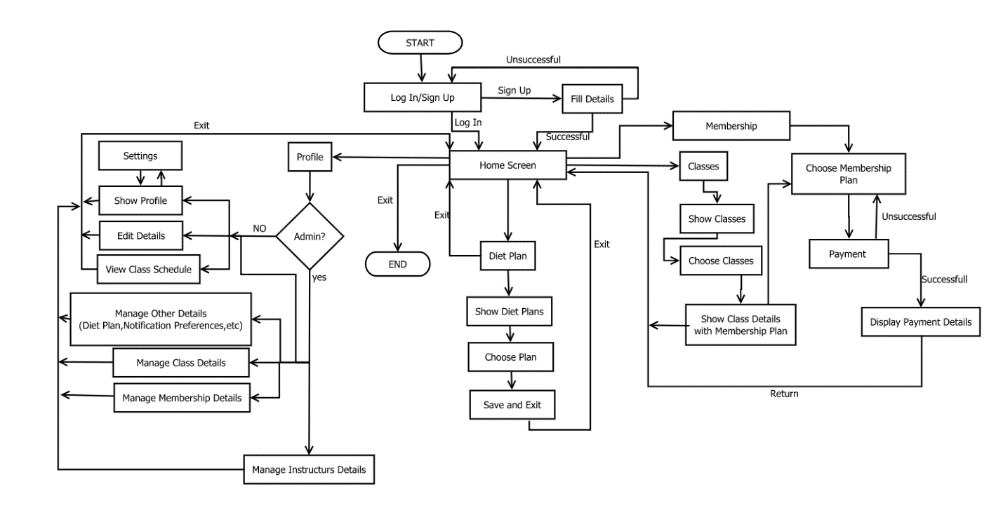

*Fig. Proposed Business Process*

# **2.0 Problems And Proposed Solutions**

## **2.1 Problems existing in system and cause and effects of problems**

According to our analysis we found many problems in current system of One Pacific Health Club which are as listed below:

|  |  |
| --- | --- |
| 1. | Not having much profit because currently they must rely on file-based system and need  more employee to handle the work, |
| 2. | Attracting less customers because of not having any online features which could really give detailed about club and club plan, |
| 3. | Problem updating club plan due to file-based system which is both time consuming and costly, |
| 4. | Problem managing membership, instructor remuneration or any other extra fees because every details are file based and need to re-read every pages of files which leads to inaccurate and faulty details or no details of members, instructor and fees |
| 5. | Because of not having proper system unable to provide good and detailed data of instructor which provide unnecessary leisure time to instructor and they are not making well income, |
| 6. | Problem producing report of any members accomplishment and history due to unmanaged data of members and their progress which demotivates members and also effects the identity and reputation of the club, |
| 7. | Problem re-reading payment details and giving necessary other details and necessary output and deliverables because of file-based system in which currently club relies which leads to loss of club because some members never pay their fees and sometimes didn’t provide all documents the club demands. |

## **2.2 Aim and Objective of the proposed system**

|  |  |
| --- | --- |
| 1. | Create a smooth-running software to fully eliminate the problem of storing data in file-based system |
| 2. | Attracting User Interface and design with interacting function to attract more users for the app |
| 3. | Function to update club plans accordingly |
| 4. | Function to manage membership |
| 5. | Function to manage personal and non-personal trainer or instructor wages and details along with extra charge fees |
| 6. | Function to produce detailed report of all members and instructors along with higher department |
| 7. | Function to manage every class and give plan and routines of every class |
| 8. | Show payment details of every member and also provide other necessary outputs & deliverables. |

# **3.0 Project Planning**

For this project we have used and followed the standard method of SDLC and created a plan to follow up in this whole software development process which we have mentioned below:

## **3.1 System Planning**

We have to develop a system to manage membership, classes personal class and payment to overcome the problem of file based system data management which is time consuming, inaccurate and costly too.

Main motto of developing this system will be:

* Accurate Data Management
* Reduce consumable time, cost and manpower
* To provide company better profits.
* After the completion of this system the company will be able to attract

## **3.2 System Analysis**

In analysis following task will be held:

* Surveys will be organized on the company premise.
* The software or system will be developed based on the users rather than company.
* Required time and cost for the completion of the app will be determined and documented.
* Required data will be provided to developer.

## **3..3 System Design**

System should have friendly user interface and easy to understand guides and titles. The system will have tabs to go to certain section like membership, profile, classes ,etc.

Specific alignments, colors and action animations will be as follows:

* Design will have UI of light blue, green and white color theme. Main theme will be white consisting text in black with action buttons in blue followed by red color for alerts and notifications in green.
* Homepage will have physical achievement or process of member in his membership class and followed by exercise tabs which are included in the class .
* All membership , classes and instructor section will have dedicated sections in and all will have its dedicated functions and options.
* The daily check inn we can say attendance screen will pop up everytime the user opens the system

## **3.4 System Implementation**

Firstly system will be published as developing and beta version. Then it will demand for users from all the sectors and then,

Implementation will be done as follows:

* The system will keep all users up-to-date about information of classes and courses or availability of instructors and personal instructors.
* The system will provide accurate and precise routine of classes and off-days to its users.
* The system will have better functions of choosing classes,
* The system will have user friendly option to choose their routine to work or train in their favorable time.
* The system will also have option to update and edit their details and membership plan.
* The system will also have recommended diet plan following the course the user is taking.

## **3.5 System Security and Support**

Good system need best security and support so following safety measurements will be applied in application:

The app will work on security strongly:

* App can be accessed using username and password the user specified while creating the account,
* The app will provide guarantee that users data won’t be leaked anywhere ,
* The company will be able to manage the routine and schedule along with instructor details and fees accordingly the system will have feature to enter the mod interface using the key they have to access the root command of the system,
* The maintenance will be made possible whenever necessary in off hours and required changes in security and other will be done accordingly.

## **3.6 Deliverables of this system**

1. Initial investigation report of what type of system and for which purpose, for whom will be prepared on planning.
2. The system requirement document of how much cost and how much time and help will be needed for fully functional system with actions needed to achieve most will be deliverable in analysis.
3. Specifications of system and its design with working algorithm, UI designs and model of app will be created and applied in design process.
4. Completely functioning and documented system will be delivered with description of how and who will use the system will be published in system implementation process.
5. A well designed app needs well designed security and support so, in this step, steps and updates that can be done in system will be noted and published.

## **3.7 Project Schedule: Gantt Chart**

The whole overview of the project is presented in Gantt Chart with details about who will do which work, how much time will it take and how the tasks will be followed by another task with mentioned cost of each project and remuneration of working persons , estimated cost and time of the project is defined in chart.

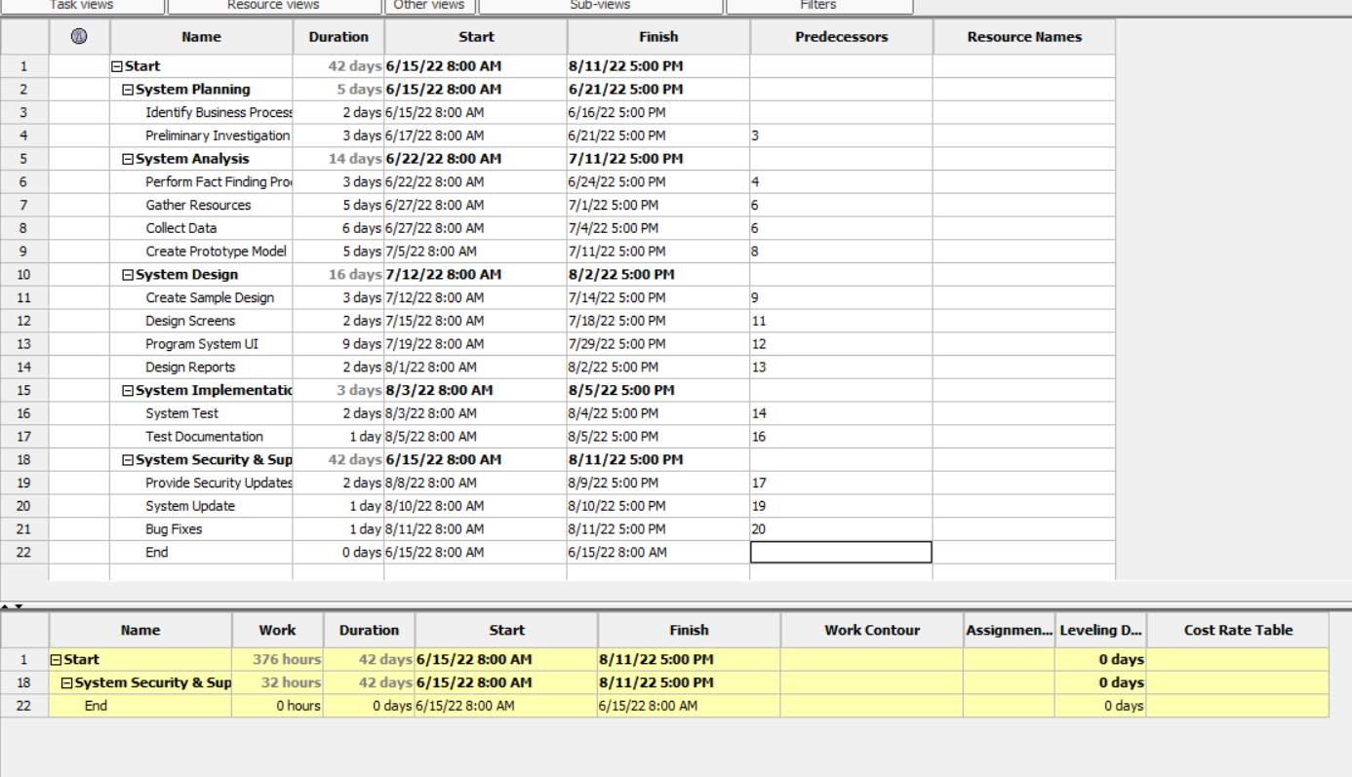

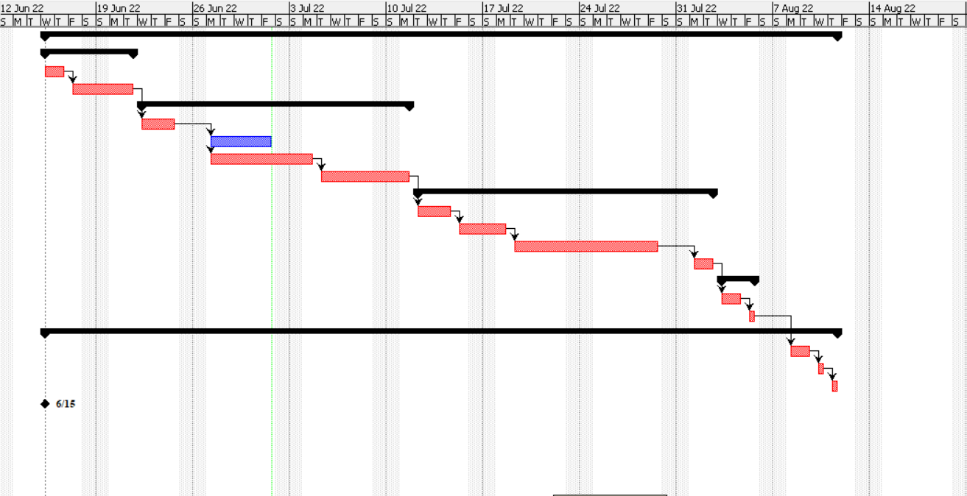

*Fig. Gantt Chart*

## **3.8 WORKLOAD MATRIX**

The workload matrix table show the percentage of each member’s contributions in this project which shows how our team members are doing and helping each other as well as in their own field. The workload matrix is shown in below table.

|  |  |  |  |
| --- | --- | --- | --- |
| Group Members | Workload | Student ID | Signature |
| Aashish Khadka | * Diagram Design * Fact Finding Technique (Case Study) * Level-1 Design(Course Flow) * Data Dictionary(Course-Data Store,Course Flow-Process) | NPI000138 | aashishhhhh |
| Adarsha Timsina | * Interface Design * Fact Finding Technique(Sampling) * Level-1 Design(Membership) * Data Dictionary(Membership-Process,Membership-Data Flow) | NPI000139 | adarsha |
| Nabin Adhikari | * System Planning * Fact Finding Technique(Questionnare) * Level-1 Design(Update Member Details) * Data Dictionary(Updating Members-Process,Member Info-Data Store) | NPI000158 | nabinn |
| Saiyam Rana | * Introduction & Business Process * Fact Finding Technique(Interview) * Level-1 Design(Update Schedule) * Data Dictionary(Update Schedule-Process,Schedule-Data Store) | NPI000171 | saiyamm |
| Sajag Shrestha | * Problem & Proposed Soluting * Aim & objectives * Fact Finding Technique(Surveys) * Level-1 Design(Payment) * Data Dictionary(Payment-Process,Payment-Data Store) | NPI000172 | sajaggg |
| Tej Bahadur Gharti Ksherti | * Feasibility Study * Fact Finding Technique(Observation) * Level-1 Design(Diet Plan) * Data Dictionary(Diet-Data Store, View Diet Plan-Process) | NPI000183 | tejjj |

Table. 1 : Table: Workload Matrix

# **4.0 Feasibility Study**

To determine the reasonable chance of success of the project feasibility study is must. The chances of project being feasible only when there is no tight budgetary and time constraints. Feasibility are of four types which are Technical, Operational, Schedule and Economic. The Operational feasibility feasibility study about the convenience of proposed project or system which determine whether the system will be easy to learn and use while technical feasibility investigate or figure if the club has enough tech resources to smoothly complete the project. And Schedule feasibility checks whether the project will finish on time while Economic feasibility asks will the company benefits more than the costs of project using the system.

### **4.1.1 Operational Feasibility Report**

This part of report gives the report of chances the proposed system will solve the business problems of One Pacific Health Club and takes full advantage of business opportunities. For this **PIECES** Framework could be helpful to find operational problems that can be solved and how much and fast they are necessary.

The **PIECES** stands for Performance, Information, Economy, Control, Efficiency and Services.

Services

Information

Economy

Control

Efficiency

Perfomance

#### ***1.Perfomanance(P)*:**

Does the proposed system gives satisfactory output and resoponse?

Yes, our system have all necessary deliverables that the company/club wants and instant response time to any input or function it deliver.

#### ***2.Information(I)*:**

Does the system currently come up with the mode that can give end users of the system and managers of system the timely, relevant , precise and fruitful format of information?

Yes, the system have very friendly and easy to use user interface to give easy and fruitful information details to its end user and managers and the system can be updated easily in clean format to give precise and timely info and all relevant information can be found sectioned in every menu section.

#### ***3.Economy(E)*:**

Economy stands to make sure if the system provide cost-effective information services for the business? Could the cost can be reduced and benefits can be increased?

Yes, the system is designed well and precisely we can assume that it can surely give the club benefit that the cost it took while developing and there can be a building-cost cut if the project finishes before estimated time for sure.

#### ***4.Control(C)*:**

If our system confirms that the system will be aware of fraud and protects from other security threats?

Yes, our company ( National Association of Software and Tech) gives all the guarantee of protect against fraud along with accuaracy and security of data and information . The system is well programmed with our best programmers who are well known to their work of security and we provide 1 year of free security check and fixes and If the data leaked found for every leaked data found we will provide 1 free update.

#### ***5. Efficiency(E)*:**

Does system make the use of available sources to the fullest?

Obviously, the system will fully make use of available resources, persons, time and forms.

#### ***6. Services(S)*:**

Can we relay on the services that the system provides, will it be expandable and flexible?

Yes, the guarantee of service is ours and the system can be always changed or expand according to need.

### **4.1.2 Technical Feasibility**

The technical feasibility determine whether our company and club both have enough resources/materials to develop and do the other steps to operate the system? Does the company have resources to operate or take the system?

Current system of One Pacific Health Club doesn’t have enough necessary resources or technology that are needed to operate the full function system or make a advance move to benefit the company. The company posses some technologies though it does not have enough or powerful system to handle the upcoming system. At this time the company has normal cheap printer which is only used to print the form and slow internet router and same for pc’s. So, the club need to upgrade every technology to rise in todays market.

As conclusion we found that the company though have resources it does not have appropriate resources. So, to provide better service One Pacific Health Club needs to upgrade to use this system to provide every work online.

### **4.1.3 Schedule Feasibility**

As we did the study there will be no delay and blunder in the process of developing software as everything goes plan and we assume that the project will be finished in time or before time but not after expected time or deadlines. And according to our study there will be no big changes in system than those mentioned in our SDLC phase which assures that or system will be finish in time.

### **4.1.4 Economic Feasibility**

Economic feasibility is carried out to determine the benefits and savings that are expected from a proposed system and compare them with cost , then decision is made to design and implement the system (Albrecht and Albrecht, 2003). This feasibility is also a must study to get most benefit from the system for One Pacific Health Club. If the developing cost exceeds the benefit cost there is no point developing the system. So, economic feasibility must study which give perspective on how the system will benefit the company and in which way it gives benefit.

The two primary components of estimated cost of proposed system are development costs and annual operating cost. This two cost determine how much cost the full system will cost. The developing cost is only one time and most of the time its high and operational cost are low compared to developing cost. For demonstration we can take a example that the PC the One Pacific Health Club will install will cost all time high when installing and maintainance will cost like 2% of its total price which is very low comparatively. The cost will exceecd developing cost in future but that will be negligible with time .

# **Cost Classification**

Cost classification can be done or divided into different costs they are:

## **Indirect/Direct Cost**

Cost that cost directly while developing system. For example buying routers and PC’s and indirect cost are like vehicle costs, delivery charges, etc.

## **Fixed/Variable Cost**

Fixed cost are cost which are already defined like paying the rent, fees, salaries, etc. while variable costs are like telephone bills which depends on activity.

## **Operational & Development Cost**

Cost that only cost once in whole system development process is development cost. For example the salaries of people working in the system development, while purchasing the software , initial tutorial or training and purchase of necessary hardware and furniture. While Operational costs are cost that occurs after the installation of the system and using it like, system maintainance, training, annual software licence and communication expenses.

Some cost apply to more than one category of cost like overtime pay for staffs in system analysis phase can be classified as direct,variable and development cost and monthly fees for maintenance can be classed as fixed, indirect and operational.

# **5.0 System Analysis**

## **5.1 Functional Requirements**

Functions and components of the system is described by the Functional Requirements of the system. A function can be described as series of inputs, outputs and actions. Functioning requirements may have data manipulation, data handling, technical details, calculations, processing and other various components our system demands for successful completion. Functional requirements can identify certain outputs from the system.

**Functional requirements of our system**

* New members are able to register without any problem.
* Schedules of class are automatically updated by the system.
* Have highly secured payment system,
* Class schedules are available for both users and trainers to view.
* The attendance of the members is done automatically by the system.
* Registering personal classes must be available to the users.
* The system must be able to verify the instructor for the personal class as customers request.

## **5.2 Non-Functional Requirements:**

Non-Functional Requirement specifies such conditions which can be used for judging the operation of the system. How a system ought to be is defined by Non-Functional Requirements. Those are features that doesn’t necessarily do much, however are important characteristics for the system. It includes things such as: user experience, compatibility, design, user interface, etc.

**Non-Functional Requirements of our system**

* Down-time for the system is lowered.
* User should be able to choose from different payment methods.
* The payments security should be ensured by the system.
* Performance should be the priority while optimizing the system.
* System should be able to handle heavy load.
* No data redundancy should occur.
* A good UI & UX should be provided by the system.
* Any changes to the schedule should be notifies to the user by the system.

# **6.0 Diagram Design**

## **6.1 Context Diagram**

Context diagram (edrawmax.com) represents all the external and internal components of the system or project. It gives easy and simple representation of the system process how and who will carry out the activity. A context diagram can help to find the bugs and errors after the complection of system and give clear guide for the system designing process.

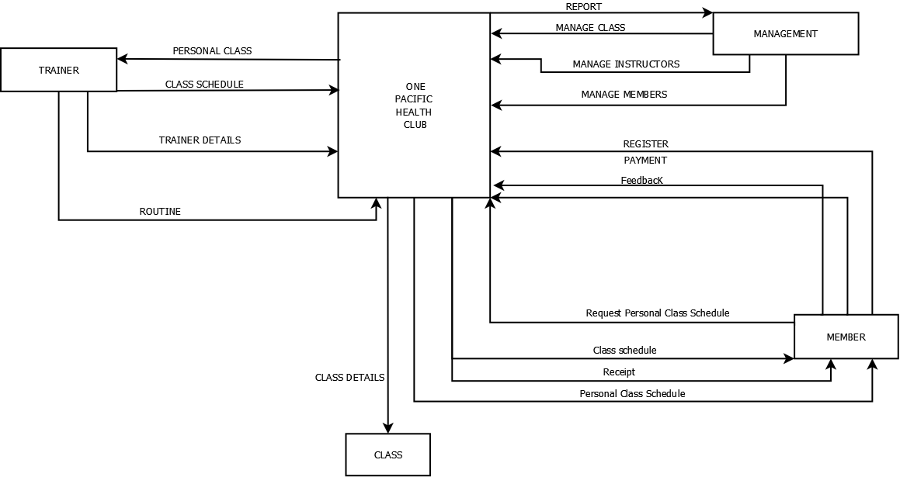

*Fig. Context Diagram*

## **6.2 Level 0 DFD**

DFD (Data Flow Diagram) is a visual or graphical representation of process applied in System Analysis and Design(SAAD) process with use of standard symbols and notation.

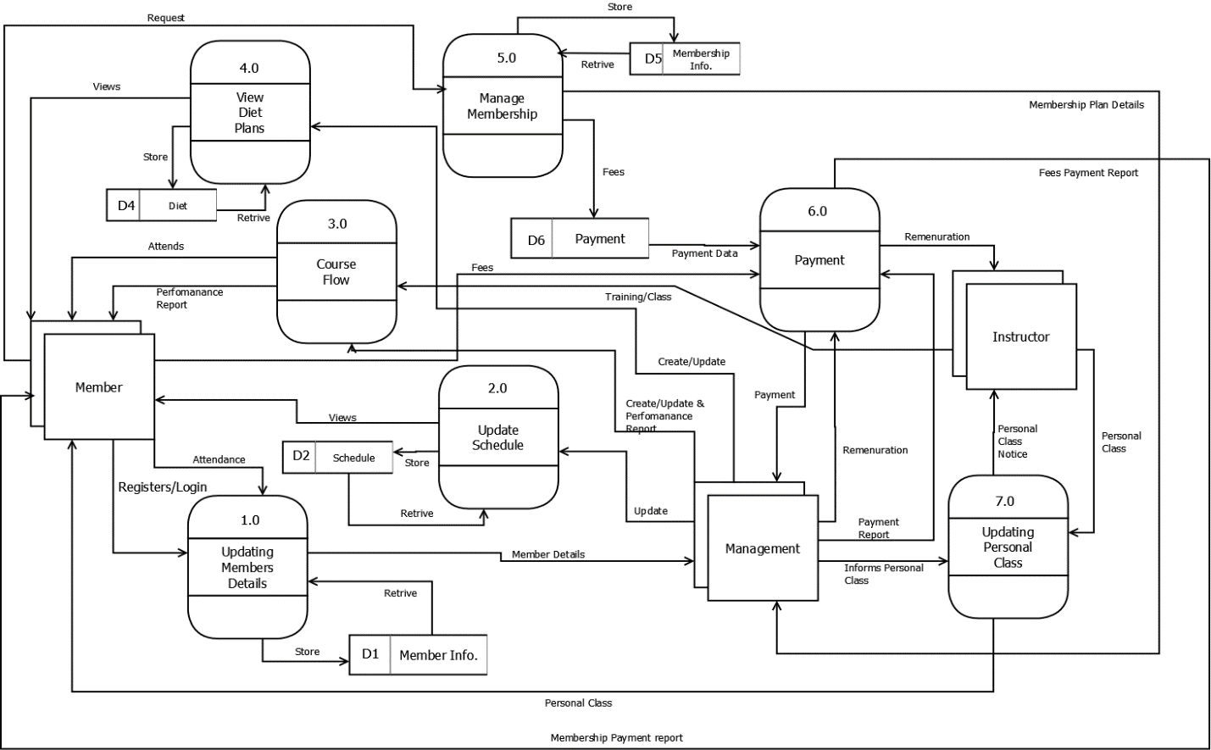

*Fig. Level 0 DFD*

## **6.3 Entity Relationship Diagram (ERD)**

An ERD is a diagram like flowchart u sed mostly while working on database schemes. The ERD have entity and condition. ERD is the figure displaying relationship between Entity and another entity by means of condition. Like a author can write books. In ER Diagram we say author and Books as entity and write as condition. The entity relationship diagram have 3 types of relationship.

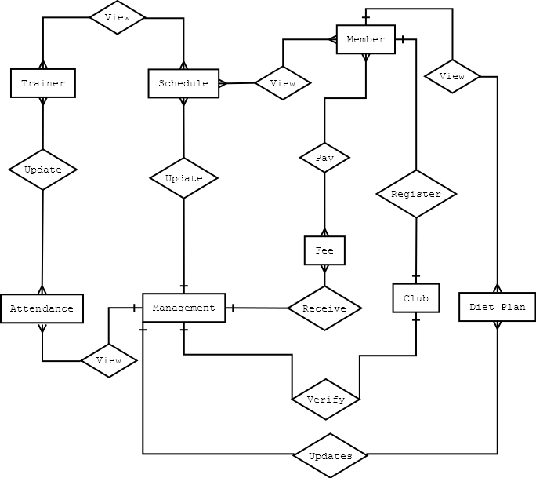

*Fig. Entity Relationship Diagarm*

# **7.0 Interface Design**

For designing this whole prototype we have used the software Figma which is a free UI/UX designing tool available and all used some images from out source like google. The whole prototype is based on Figma originally.

## **7.1 Startup Screen**

This interface shows the first screen of the system before login or sign up. The user can login or register from this interface. This interface contains buttons for login,signup and login as admin and have the app name as ‘OP Fit’ on the top.



*Fig.Startup Screen*

## **7.2 Sign Up Screen**

This interface provides feature of signing up or registration function to the user. In this section user can fill up his details and create a acount filling details like full name,date of birth and email and need to create a password and confirm that.

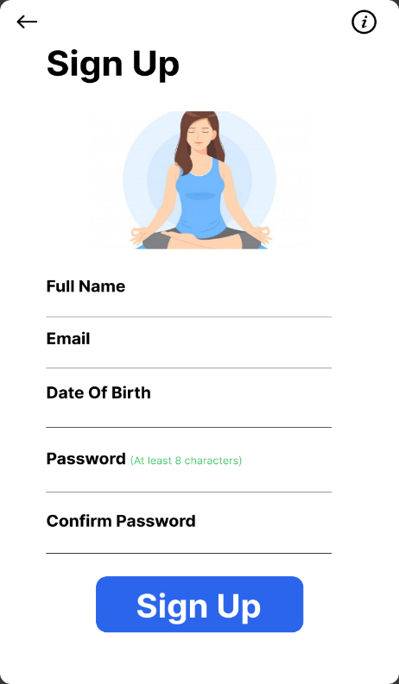

*Fig. Sign Up Screen*

## **7.3 Login Screen**

This interface provide the feature of login in for the user to login in the application using his credentials he used while registering in the application. Like s/he needs to enter the username she created for registration and password to login into his/her account.

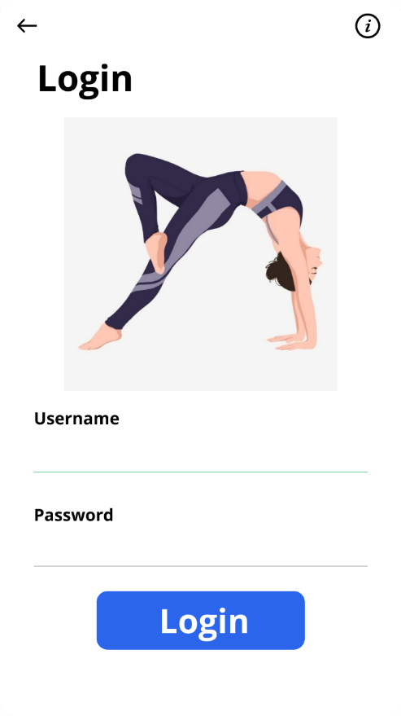

*Fig. Login Screen*

## **7.4 Home screen**

This is the main screen of the system. In this screen user can see all the options available or feature of the application. This tab contains the Profile tab where user can see his details, diet plan tab for choosing and following diet, on courses tab one can access and see details of the courses available and membership tab provides the user with the membership activity and membership details along with the days left in membership and buttons to buy another membership or renew the existing membership at any moment.

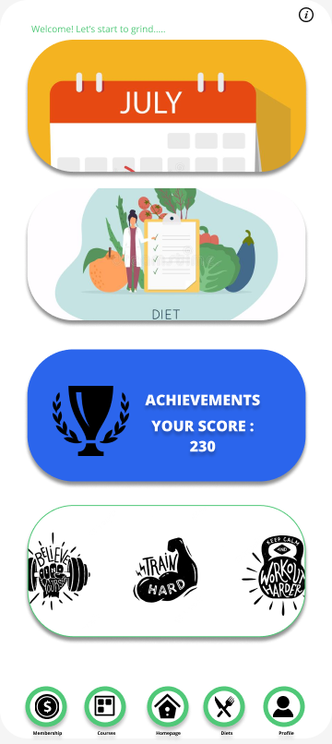

*Fig. Home Screen*

## **7.5 Attendance pop up**

This pop is after user join the membership and opens up the application. This pop up will show everyday the user opens the application and the user will have option to check in and if he cancels the pop up his attendance will not be registered.

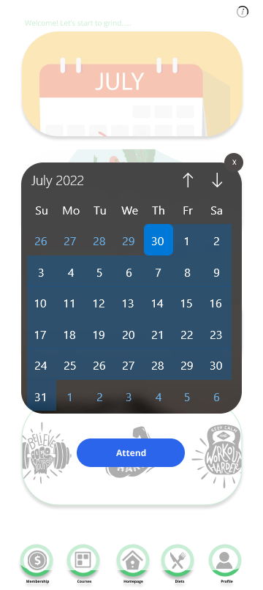

*Fig. Attendance Pop-up Screen*

## **7.6 Profile Tab**

This tab provides the information of the user where s/he can view own details like viewing name and email and can upload own profile picture and his achievements in membership and how s/he is doing the performance. Along they can view their payments records or history . And in profile tab one can find option to logout or if admin they can access administration settings.

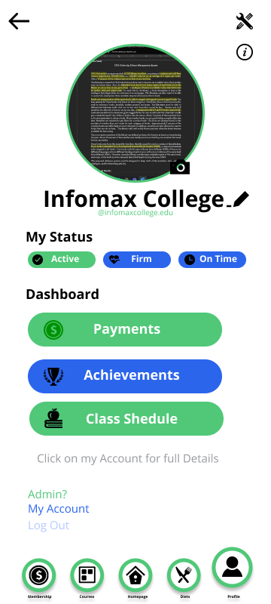

*Fig. Profile Tab*

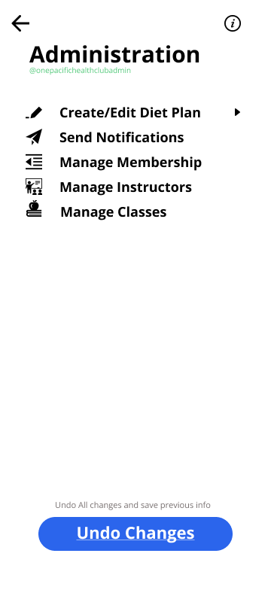

*Fig. Administration Settings*

## **7.7 Diet Plan Tab**

This tab provides the user with the customized diet plan for specific courses which user can choose and follow with and also choose new plan as he like. We have the plans like plan A,plan B,plan C and so on.

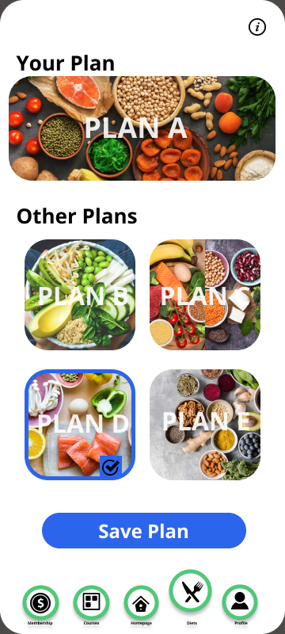

*Fig. Diet Plan Tab*

## **7.8 Courses Tab**

This tab provides the user with the available courses and his course in which they are enrolled. The user can select any of the courses and see the details of the courses and their membership cost for the specific time and can choose to purchase if they want.

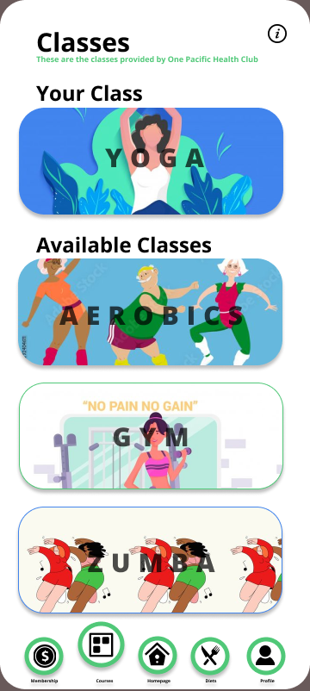

*Fig. Courses/Classes Tab*

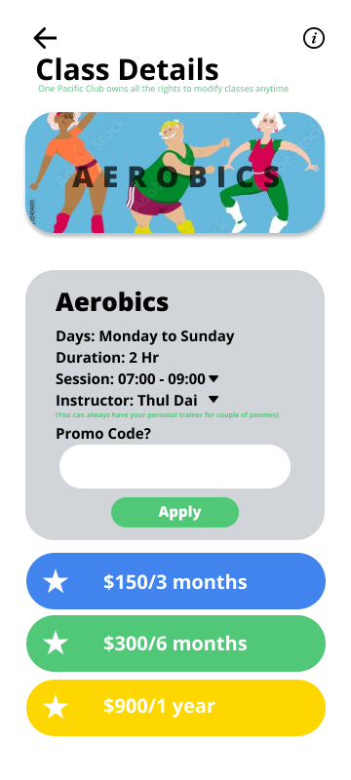

*Fig. class Details*

## **7.9 Membership Tab**

This tab let the user view his membership status if already purchased and if not purchased it will show the membership options available and their cost. This tab shows the days of membership and the subscription plan for different kinds of membership.

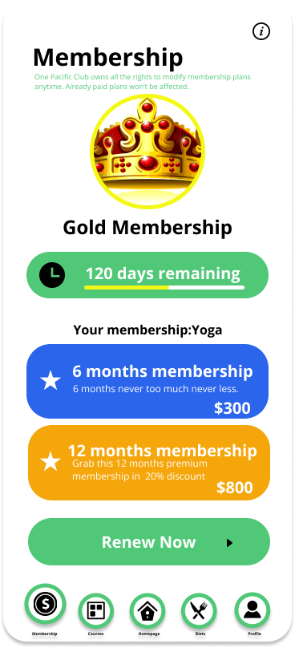

*Fig. Membership Tab*

## **7.10 Payment Screen**

This tab let the user pay the membership using the methods available for the purchase and they need to fill the form with card number if card selected and another method available is PayPal for which phone no is needed.

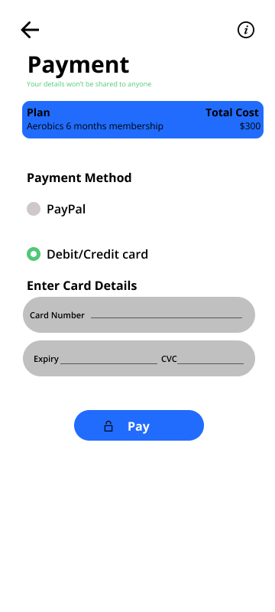

*Fig. Payment Screen*

## **7.11 Payment Confirmation Screen**

This screen shows the user with the alert or confirmation purchase of the membership with how much and for whom they are paying.

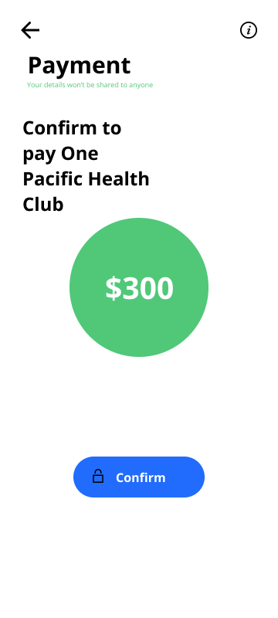

*Fig. Payment Confirmation Screen*

## **7.12 Payment Successful Report**

This screen print the report of the payment whether it is successful or failed with details they are paying for and amount they paid along with other details like what was the method and who processed.

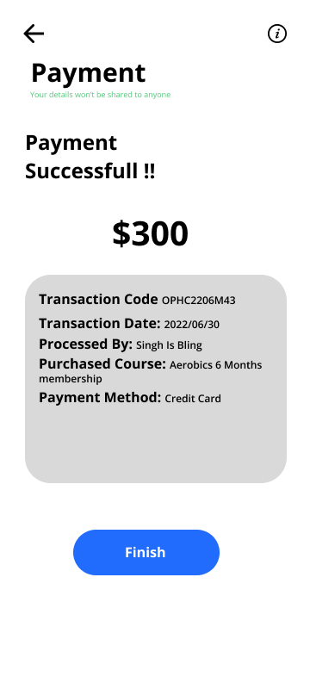

*Fig. Payment Successful Screen*

# **8.0 Requirement Gathering**

## **8.1 Interview (NPI000171,Saiyam Rana)**

Interview refers to one-on-one conversation which is done one person acts in role of interviewer and another person acts of interviewee. Typically, the interviewer asks questions and the interviewee responds to gather information about a specific topic. Interview can be done by face to face meeting or via internet and telephone line. (Shelly and Rosenblatt,2012)

**Advantages of interview:**

1. It cost less money compare to the other techniques.
2. Interviews can study the body language of the person giving the interview.
3. Interview can help finding the right candidate.
4. Proper analysis can be done.
5. Flexible way for gathering information.

**Disadvantage of interview:**

1. Interview deliver biased responses.
2. Dealing with refusal.
3. Time consuming.
4. No close attention can cause missing of details.
5. Personal conflicts may take place during the interview

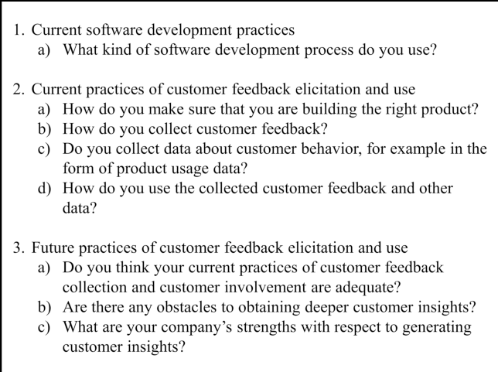

*Fig. Interview Sample Questions*

*(researchgate.com)*

## **8.2 Questionnaire(NPI000158,Nabin Adhikari)**

A questionnaire is a research featuring a series of questions used to collect useful information. These method may include written or oral questions and have an interview like format. Questionnaires can be held online, on paper or face-to-face, and questions should not necessarily be from administration.

**Advantage of questionnaire:**

1. Practicality
2. Speed
3. Comparability
4. Easy analysis
5. Cost-efficiency
6. Scalability
7. Respondent comfort

**Disadvantage of questionnaire:**

1. Analysis challenges
2. Survey fatigue
3. Question skipping
4. Answer dishonesty
5. Interpretation difficulties
6. Unconscientious responses

## **8.3 Observation(NPI000183,Tej Bahadur Gharti Kshetri)**

In this method the analyst himself visit organization and observe or understand the flow of documents, working on the already resting system, or other staffs or users and everything existing in that area or company. For this, a highly qualified analyst is required or needed to perform the job as he needs much more about analysis and can point out the problems and issues.

**Advantages of Observation:**

1) Easy to conduct

2) Have high accuracy

3) Standard method

4)Observation is not appropriate or every cases

5) Independent of people’s choice

**Disadvantages of Observation:**

1. Not openness occurs every time
2. Every occurrences may not lend themselves to observational study
3. Can’t rely
4. May have false perception
5. Delayed investigation
6. Costly
7. Not enough
8. Validation check is hard.

## **8.4 Sampling(NPI000139,Adarsha Timsina)**

This method has two different mehods. First, the analyst will collect all needed data and information of the existing system and prepare blank documents and put on a work . And where he find errors or see something necessary he captures or records the data to understand the system and find the possible solution. 2nd way is analyst can carry out a analysis of the document in order to find the patterns and data needed . For, example analyst may carry out different methods to know or deliver the exact solution. Like, he can choose any form of paper or electronic data and sample best out of that.

**Advantages of Sampling:**

1. Less expensive
2. Timely
3. Larger scope
4. Proficient data accuracy
5. Convenience of company
6. In Depth and complete data
7. Works with less and limited resources
8. Well balanced report

**Disadvantages of Sampling:**

1. Sometimes unfair reports may be produced.
2. Hard to select true representing sample.
3. Not enough subject knowledge.
4. Unpredictable

## **8.5 Surveys (NPI000172, Sajag Shrestha):**

Starting a survey allows one to collect meaningful and important information from the users in a short span of time, also helpful for having a good interaction with users from all around the globe with minimal budget and time constraints.

**Things to consider while preparing for your survey:**

1. Keep it short so people are more likely to complete it.
2. Focus on a single feature or topic, rather than many at once.
3. Use a rating system for data analysis with responses like: “agree” or “disagree”.
4. To get detailed input have some open-ended questions.
5. Use the six question words (who, what, when, where, why and how) to structure the survey for the best results.

**Advantages**

1. Executable in a short period of time.
2. Cost-effective, depending on how the survey is structured.
3. Being able to administer remotely via online, mobile devices, etc.
4. Conducting the survey remotely can reduce or prevent geographical dependency.
5. Advance techniques can be used for analyzing..

**Disadvantages**

1. Users may give false information.
2. Users may have less knowledge which can leads to inaccurate and formed by own answeres.
3. Users may not provide answers that may present them in an unfavorable manner.
4. Closed-ended questions in a survey might have a lower validity rate than any other types of questions.
5. There can be differences in how people understand the question in a survey.
6. Users may choose to answer without reading any questions.

## **8.6. Case Study (NPI000138, Aashish Khadka)**

A case study is a type of investigation that typically concentrates on gathering data about a specific person, group, or organization before using that data to develop a clear understanding of that subject.

Advantage

1. It can done remotely.
2. It is inexpensive.
3. Accessible to reader.
4. By the end of the research we can get in depth knowledge.

Disadvantage

1. This method may be in-effective.
2. It takes longer time to analyzes the data.
3. Data collection is a strenuous work.
4. It may take long time to study.

# **9.0 Design**

## **9.1 Data Dictionary**

### **9.1.1 Diet (Data Store)(NPI000183,Tej Bahadur Gharti Kshetri)**

**Description**

Stores updated diet plans & their details

**Input**

Updated Diet Plan

Selected diet plan

**Output**

Send selected diet details

Show all diet details

**Data Structure**

Diet= Updated Diet Plan + Selected Diet Details

### **9.1.2 View Diet Plan(Process)(NPI000183,Tej Bahadur Gharti Kshetri)**

**Description**

It will get users and admins details and provide function like viewing and choosing plan for users & viewing & updating functions for admins.

**Input**

Updated Diet Plan

**Output**

Existing diet details

**Process Description**

1. START

2. FOR every user

3. Display Diets plans

4. IF personal choice receivd

Confirm Diet Plan

Store Date

5. Else

Only show details.

6.End

### **9.1.3 Membership (Data Flow) (NPI000139,Adarsha Timsina)**

**Description**

Stores data about membership subscription

**Input**

Membership Request data

**Output**

Membership Details Update

**Data Structure**

Membership=requests+updates

### **9.1.4 Membership(Process)(NPI000139,Adarsha Timsina)**

**Description**

Receives membership request from members and sends the information to management

**Input**

Membership request from member

**Output**

Membership request and details of the member

**Process Description**

1. START

2. FOR every user

Receives request

3. IF

Request is valid

Send to payment process

4. IF

Payment is done

Send info to management

5.ELSE

Hold the request

6.ELSE  
 Decline the request

7. Provide membership

8. END

### **9.1.5 Payment (Data Store) [NPI000172, Sajag Shrestha]**

**Description:**

Stores payment details

**Input:**

Payment method

Card details

**Output:**

Payment details

**Data Structure:**

Payment = Payment method + Card details

### **9.1.6 Payment (Process) [NPI000172, Sajag Shrestha]**

**Description:**

This process provides user with payment methods in which user can choose to pay from. Where after choosing, they need to give in their card details for processing to complete the transaction.

**Input:**

Payment method

Card details

**Output:**

Payment details

**Process Description:**

Start

For every user

Receives payment method options

Both of which leads to a card detail menu

IF

User enters their card details

Sends for payment processing

ELSE

Transaction failed

Sends Payment details

* END

## **9.1.7 Updating Member Details (Process) [NPI000158, Nabin Adhikari]**

**Description**

Collect members detail and update it.

**Input data**

Members previous detail.

**Output data**

Updated details of members.

Process:

Previous details of members to new updated details of members.

## **9.1.8 Member Info (Data Store) [NPI000158,Nabin Adhikari]**

**Description:**

Inform members about updated details.

**Input data:**

Process to update member details

**Output data**

Updated  members detail received by members.

## **9.1.9 Update Schedule(Process)[NPI000171, Saiyam Rana]**

Description

New updated schedule.

Input data:

Received update and change schedule.

Output data

Update new schedule to members.

Process:

Change schedule updated to members.

## **9.1.10 Schedule(Data Store) [NPI000171, Saiyam Rana]**

**Description:**

Updated schedule views by members.

**Input data**

Change previous schedule.

**Output data**

Update change schedule to members.

## **9.1.11 Course Flow (Process)[NPI000138, Aashish Khadka]**

Name: 3.0 Course Flow

Description: Updating member performance report

Input Data: Creating performance report

Output Data: Updating performance report

Process: Collecting member performance report and updating report

## **9.1.12 Course (Data Store)[NPI000138, Aashish Khadka]**

Name: Course Flow

Description: Informing members their performance report

Input Data: Process to inform member performance report

Output Data: Updating members through process

## **9.2 Level 1 DFD**

### **9.2.1 Diet Plan DFD Level 1 DFD (NPI000183, Tej Bahadur Gharti Kshetri)**

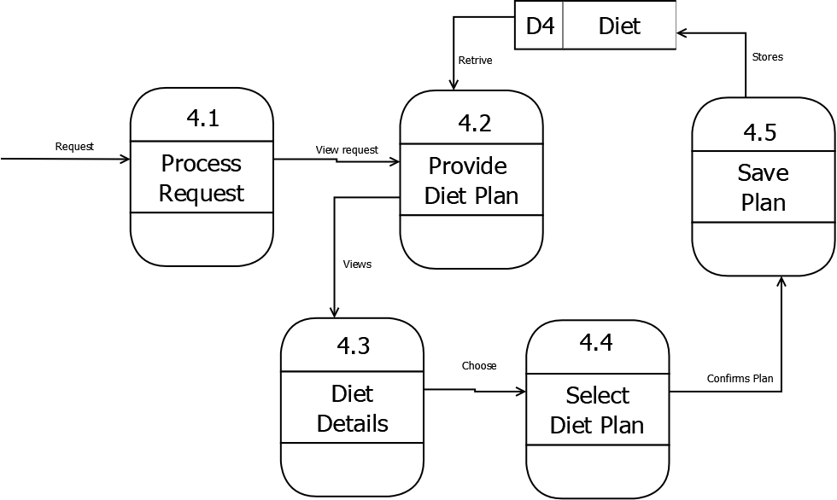

*Fig.Diet Plan(LEVEL 1 DFD)*

### **9.2.2 Membership Level 1 DFD( NPI000139, Adarsha Timsina)**

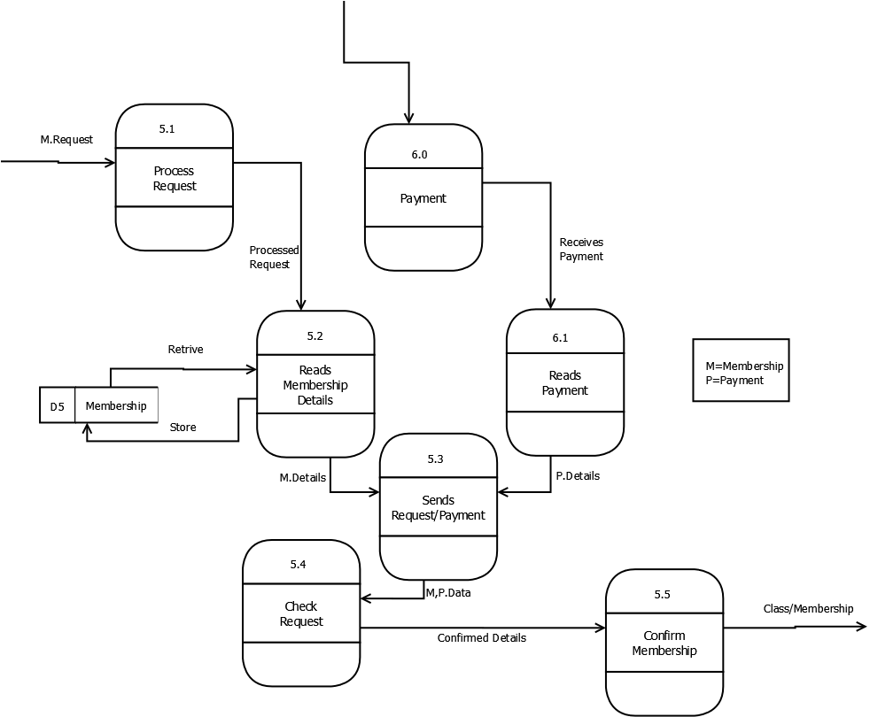

*Fig.Membership (Level 1 DFD)*

### **9.2.3 Payment Level 1 DFD [NPI000172, Sajag Shrestha]**

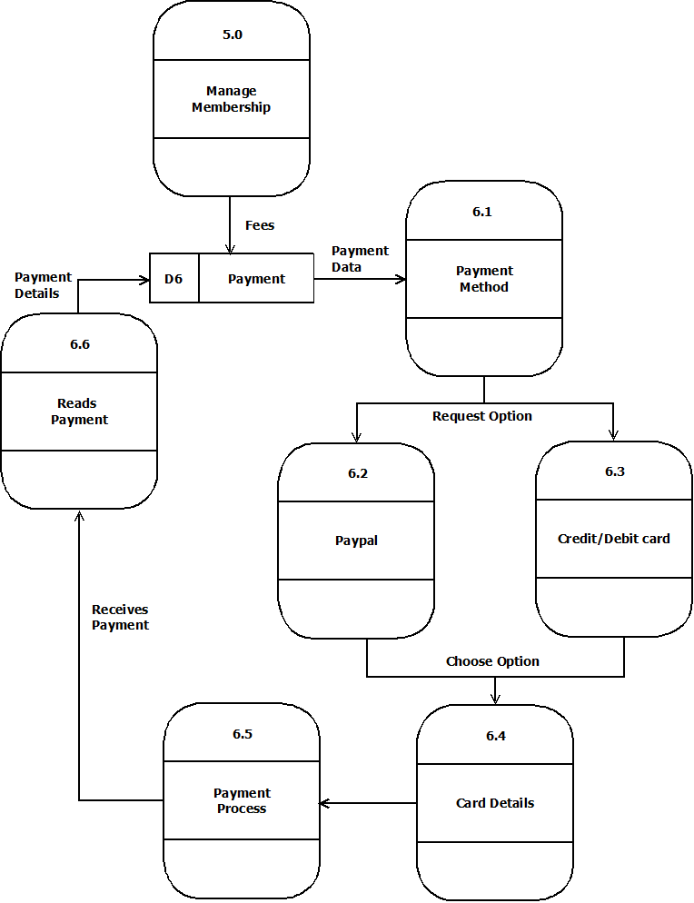

*Fig.Level 1 DFD (Payment)*

### **9.2.4 Update Member Details Level 1 DFD [NPI000158, Nabin Adhikari]**

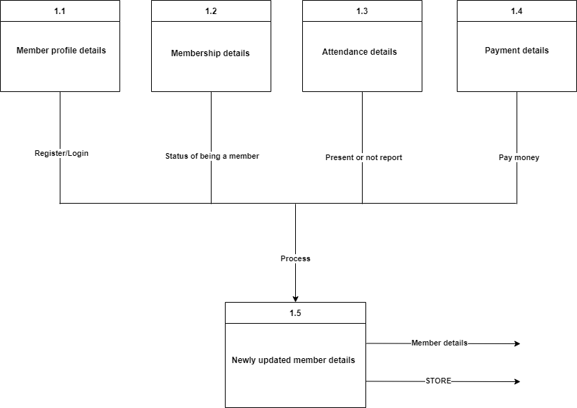

*Fig. Level 1 DFD ( Update Member Details)*

### **9.2.5 Update Schedule Level 1 DFD [NPI000171, Saiyam Rana]**

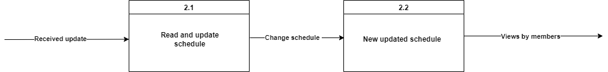

*Fig. Level 1 DFD ( Update Schedule)*

## **9.2.6 Course Flow Level 1 DFD[NPI000138, Aashish Khadka]**

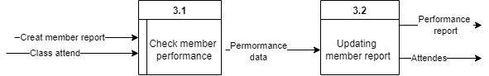

*Fig. Level 1 DFD (Course Flow)*

# **Conclusion**

In conclusion we can say that we have given our efforts as we could and done this project which surely developed our skill of documentation with the other knowledge about the System Analysis and Development. Although we have done partition of project, like we have done 1 part in total 6 parts of the assignment but this helped us with our time management and working as a team and it was a challenging task for us.

***References***

*Economic Feasibility [Bibliography],2003, Albrecht and Albrecht*

*Definition of Interview [Bibliography],2012,Shelly and Rosenblatt*

*Advantages and disadvantages of observation, [Online] Available at Articlesavenue.weebly.com*

*Advantages and disadvantages of sampling, [Online] Available at Accountlearning.com*

*Observation and Sampling [Online] Available at Yourarticlelibrary.com*